Game Design Document

Fill up the following document

1. Write the title of your project.

Arcane the runner

1. What is the goal of the game?

To make the player reach the finish line

1. Write a brief story of your game.

The player has to collect points and dodge the obstacles in they way such

as rocks. There will be a finish line once he completes 100 of distance.

1. Which are the playing characters of this game?

* Playing characters are the ones who respond to the user based on the input from the user.
* Cars, monkeys, dinos, wizards, etc., are the playing characters in the game.

|  |  |  |
| --- | --- | --- |
| Number | Character Name | What can this character do? |
| 1 | Arcane | Running |
| 2 |  |  |
| 3 |  |  |
| 4 |  |  |
| 5 |  |  |
| 6 |  |  |
| 7 |  |  |
| 8 |  |  |

1. Which are the Non-Playing Characters of this game?

* Non-Playing characters are the ones that don't have an action or behavior when the user interacts with the game.
* Hurdles, stones, bananas, coins, etc., are non-playing characters in the game.

|  |  |  |
| --- | --- | --- |
| Number | Character Name | What can this character do? |
| 1 | Rocks | The player has to dodge the rocks |
| 2 | Points | The player has to collect the points |
| 3 |  |  |
| 4 |  |  |
| 5 |  |  |
| 6 |  |  |
| 7 |  |  |
| 8 |  |  |

Draw your imagination of this game. What does this game look like?

* Draw the game either on your computer or on paper.
* Add images of the game scenes to show each of the playing and non-playing characters at least once.

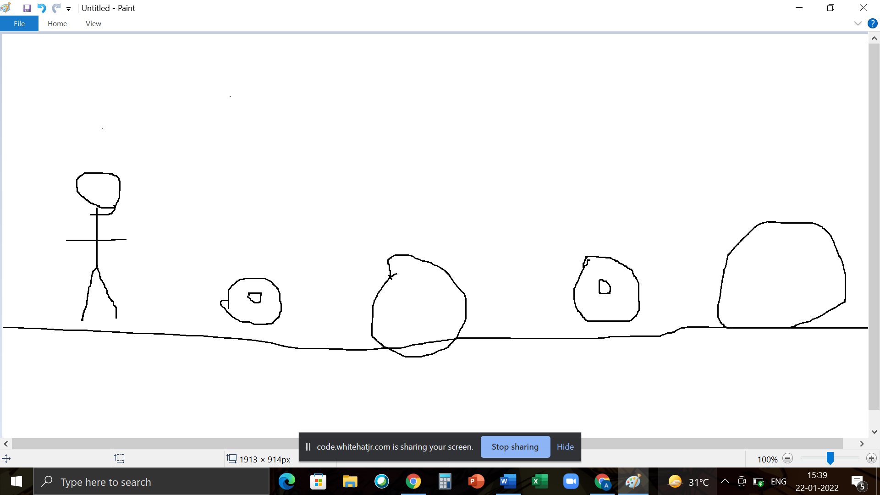

How do you plan to make your game engaging?

To make it more engaging I’ll make the game faster and increase the number of obstacles